C. Shaass and Lights
time limit per test
1 second
memory limit per test
256 megabytes
input
standard input
output
standard output
There are n lights aligned in a row. These lights are numbered 1 to n from left to right. Initially some of the lights are switched on. Shaass wants to switch all the lights on. At each step he can switch a light on (this light should be switched off at that moment) if there's at least one adjacent light which is already switched on.
He knows the initial state of lights and he's wondering how many different ways there exist to switch all the lights on. Please find the required number of ways modulo 1000000007 (109 + 7).
Input
The first line of the input contains two integers n and m where n is the number of lights in the sequence and m is the number of lights which are initially switched on, (1 ≤ n ≤ 1000, 1 ≤ m ≤ n). The second line contains m distinct integers, each between 1 to n inclusive, denoting the indices of lights which are initially switched on.
Output
In the only line of the output print the number of different possible ways to switch on all the lights modulo 1000000007 (109 + 7).
Examples
input
Copy
3 1
1
output
Copy
1
input
Copy
4 2
1 4
output
Copy
2
input
Copy
11 2
4 8
output
Copy
6720

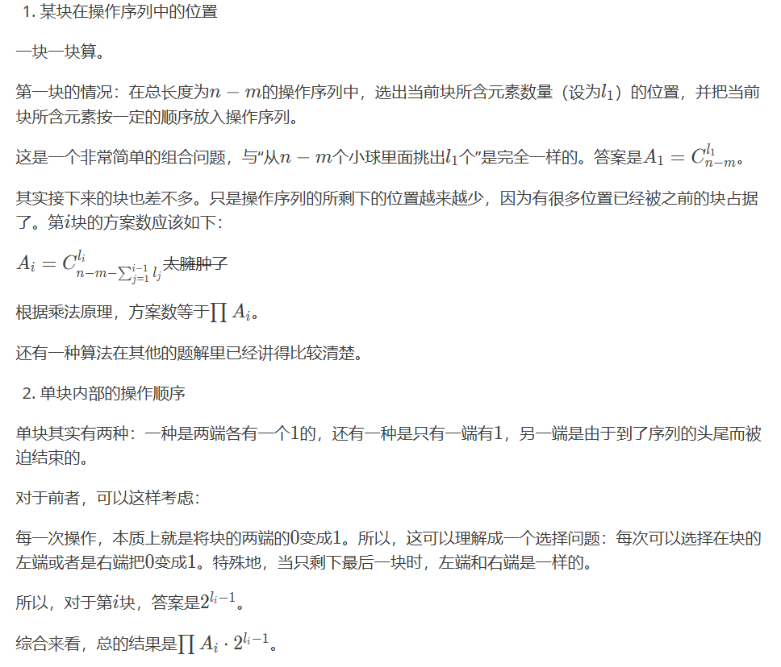

然后小知识。。因为那么多块总数加起来等于sum。
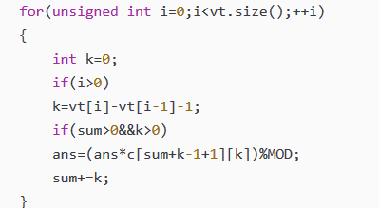 所以sum=0开始加
和我下面的写的算了后再减，是一样的

#include<iostream>
#include<cstdio>
#include<cstring>
#include<algorithm>
#include<map>
#include<queue>
#include<vector>
#include<cmath>
#define ll long long
using namespace std;
ll pow2[2005];
vector<int> G;
ll c[2005][2005];
const ll mod=1e9+7;
int main()
{
for(int i=0;i<2000;i++)
{
for(int j=0;j<=i;j++)
{
if(j==0) {c[i][j]=1;continue;}
if(i==j) {c[i][j]=1;continue;}
c[i][j]=(c[i-1][j-1]+c[i-1][j])%mod;
}
}
pow2[0]=1;
for(int i=1;i<2000;i++) pow2[i]=(pow2[i-1]*2)%mod;
int n,m;
scanf("%d %d",&n,&m);
for(int i=1;i<=m;i++)
{
int x;
scanf("%d",&x);
G.push_back(x);
}
sort(G.begin(),G.end());
ll ans=1;
for(int i=1;i<G.size();i++)
{ ll kk=G[i]-G[i-1]-1;
if(kk>=1)
{
ans=(ans*pow2[kk-1])%mod;
ans=ans%mod;
}
}
G.insert(G.begin(),0);
G.push_back(n+1);
int sum=n-m;
for(int i=1;i<G.size();i++)
{
int kk=G[i]-G[i-1]-1;
if(sum>0&&kk>0)
{
ans=(ans*c[sum][kk])%mod;
ans=ans%mod;
}
sum-=kk;
}
cout<<ans;
return 0;
}

